ITD 3663 Mobile Programming Grade **__95__**

Instructor: J. Strother

Student Name: Derrick McFall

Due Date: October 14, 2018

Gradebook Comments: need to show more of your work.

## Module Six Aloha Music

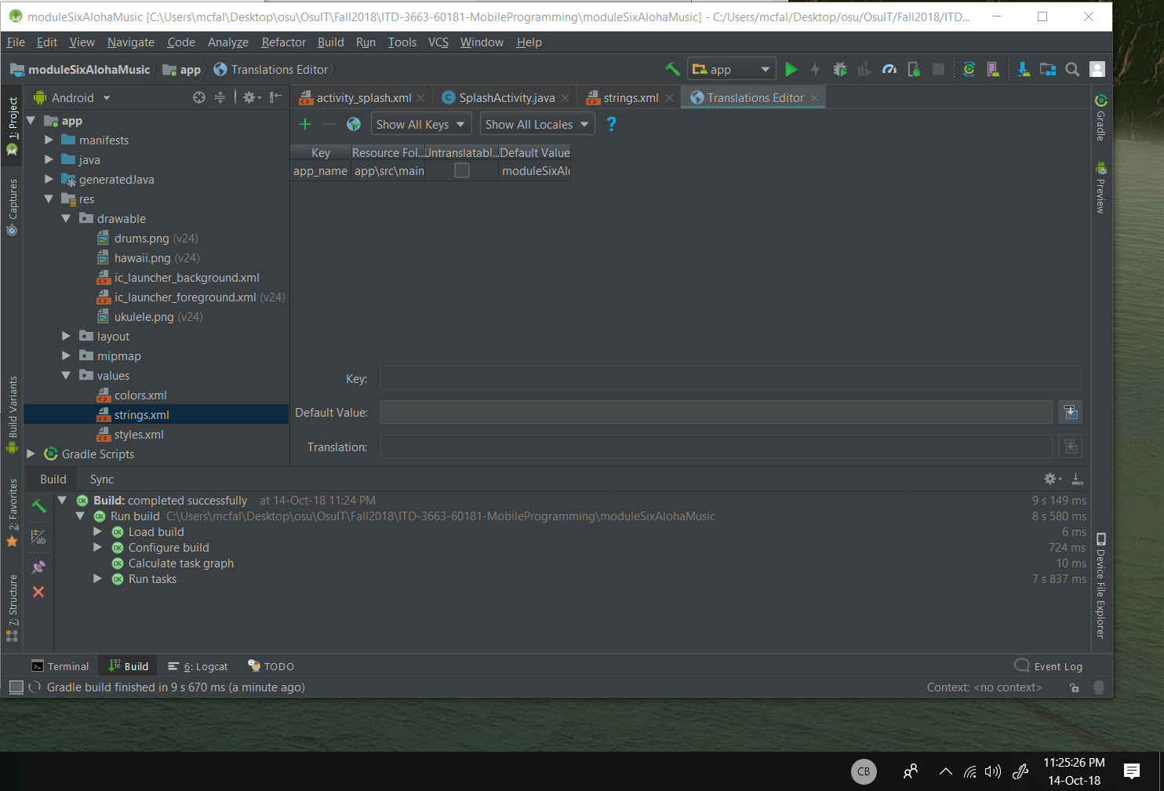

The process of creating a project is almost identical to the other so I skipped that.

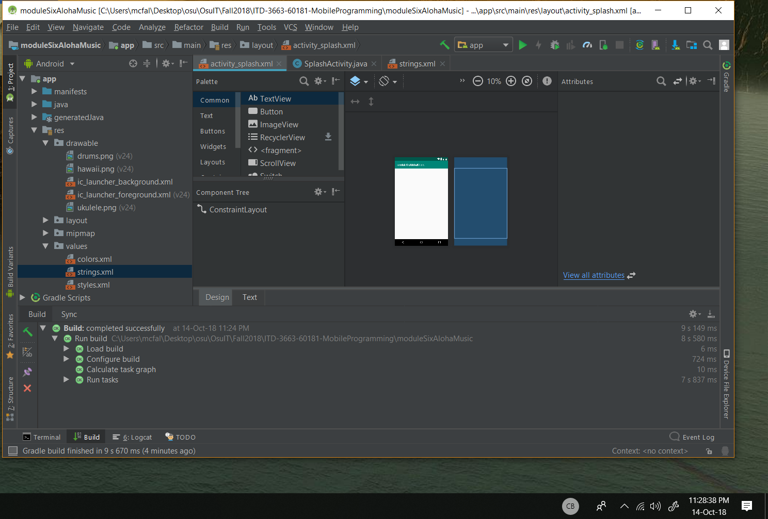

Deleted the hello world text view.

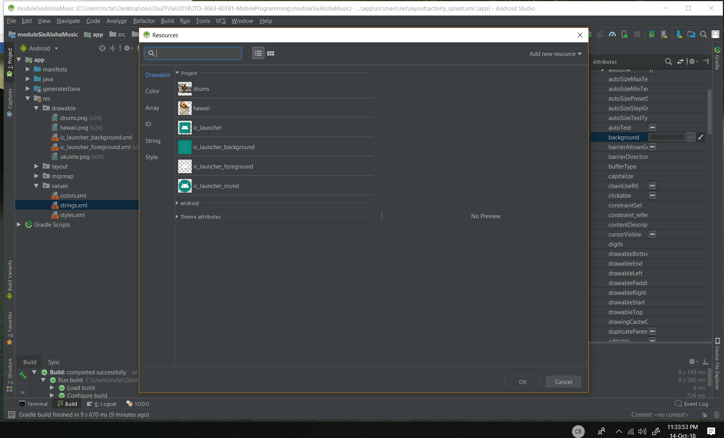

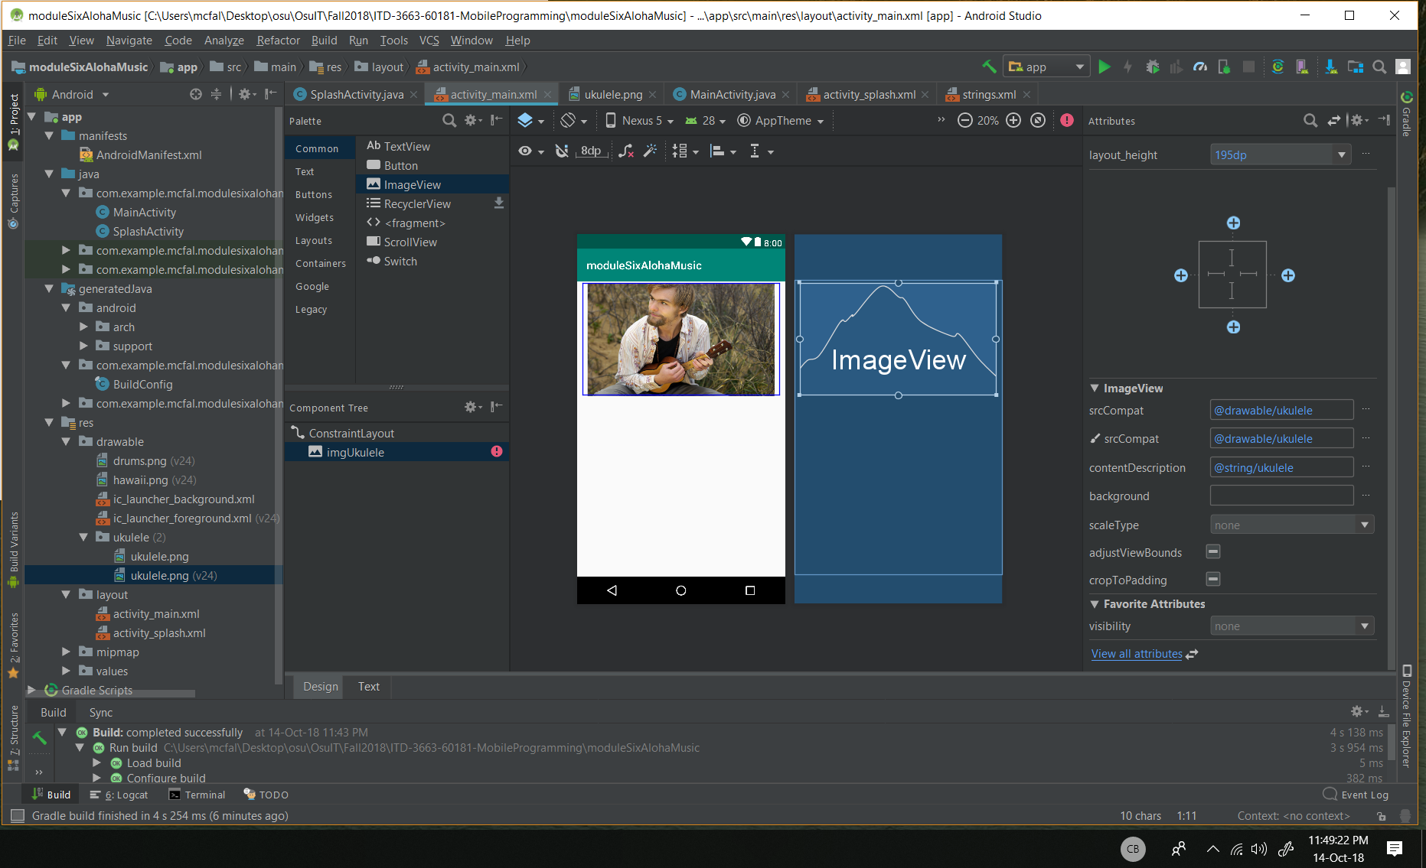

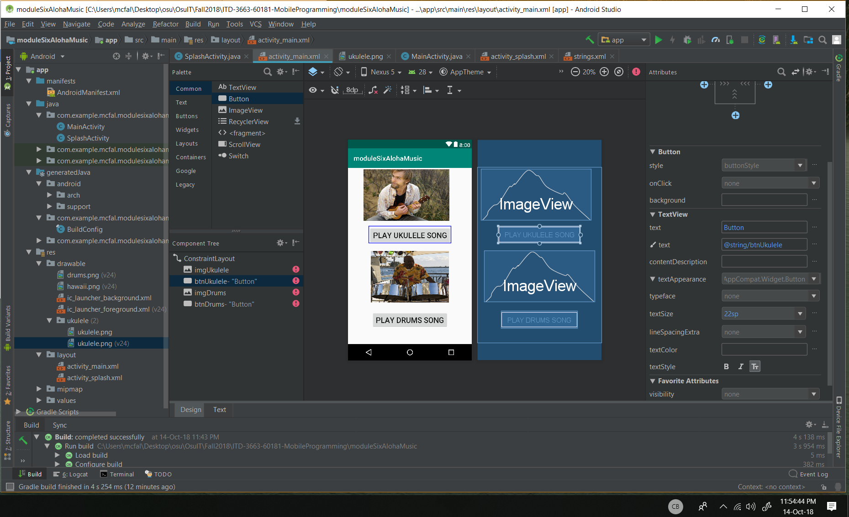

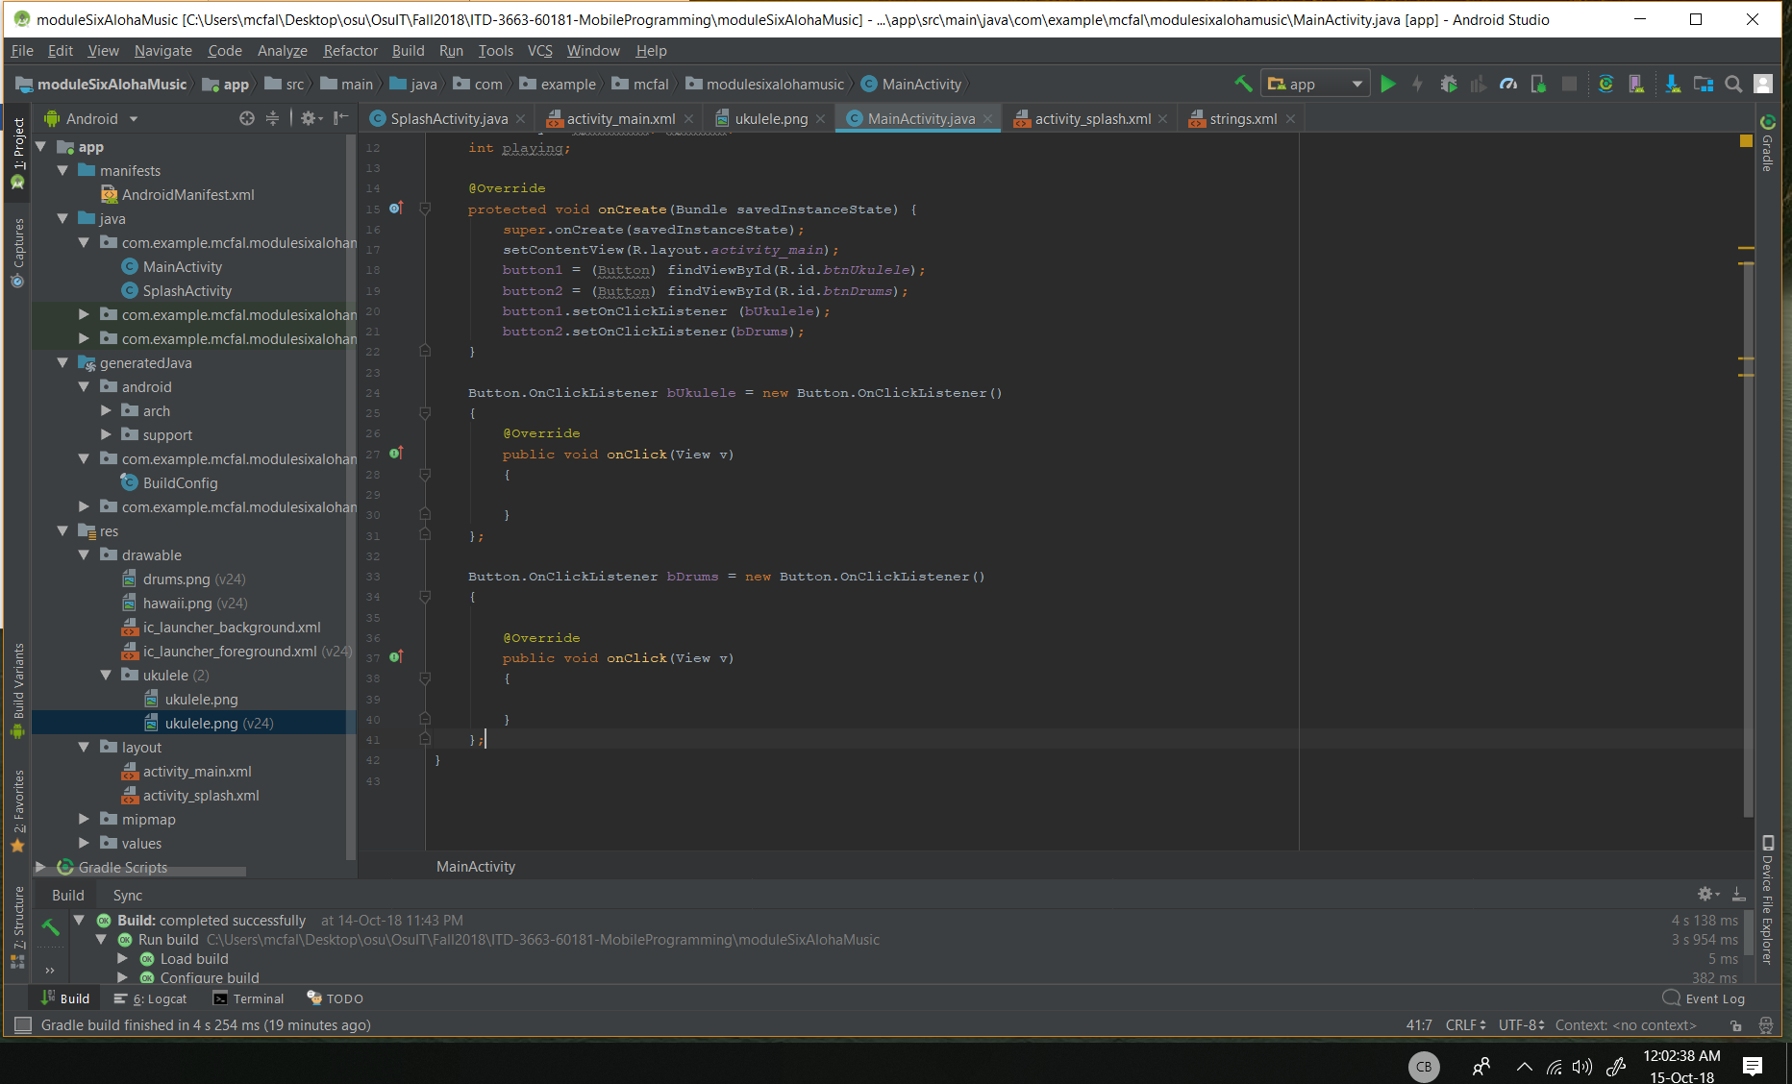

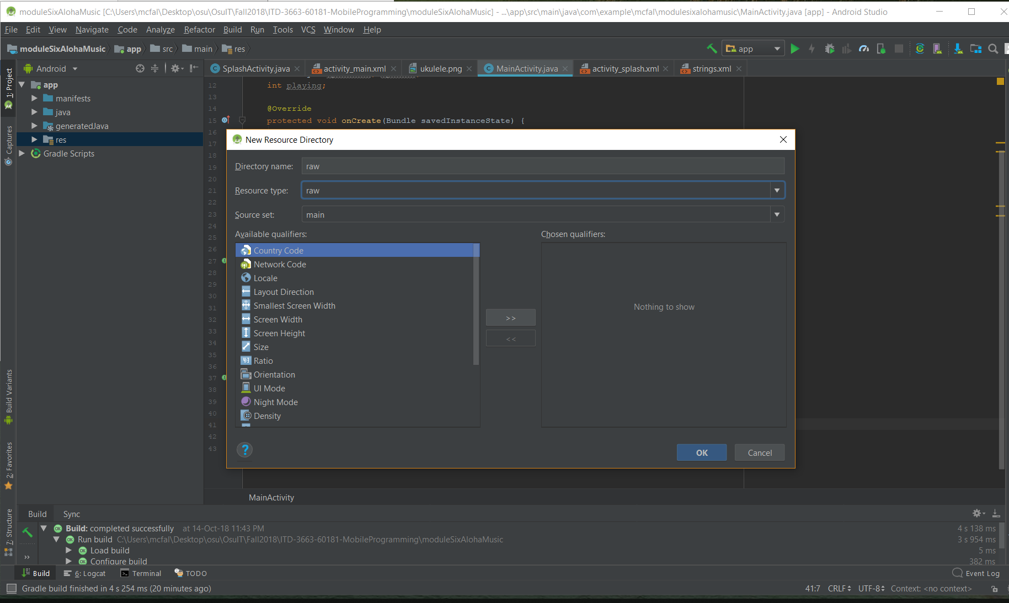

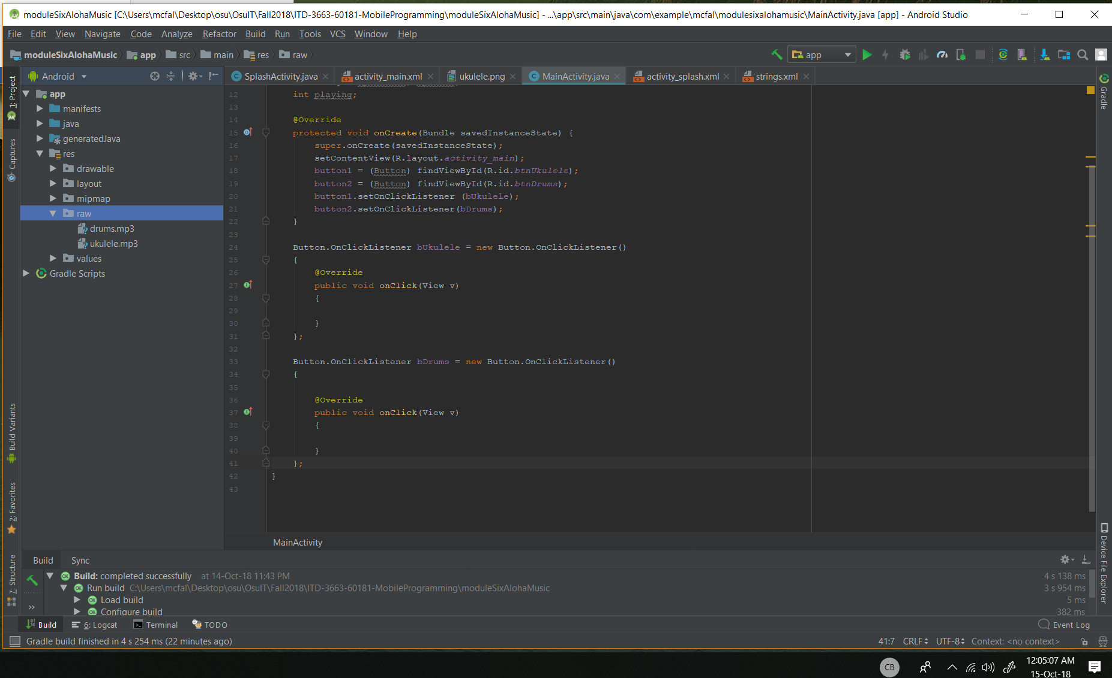

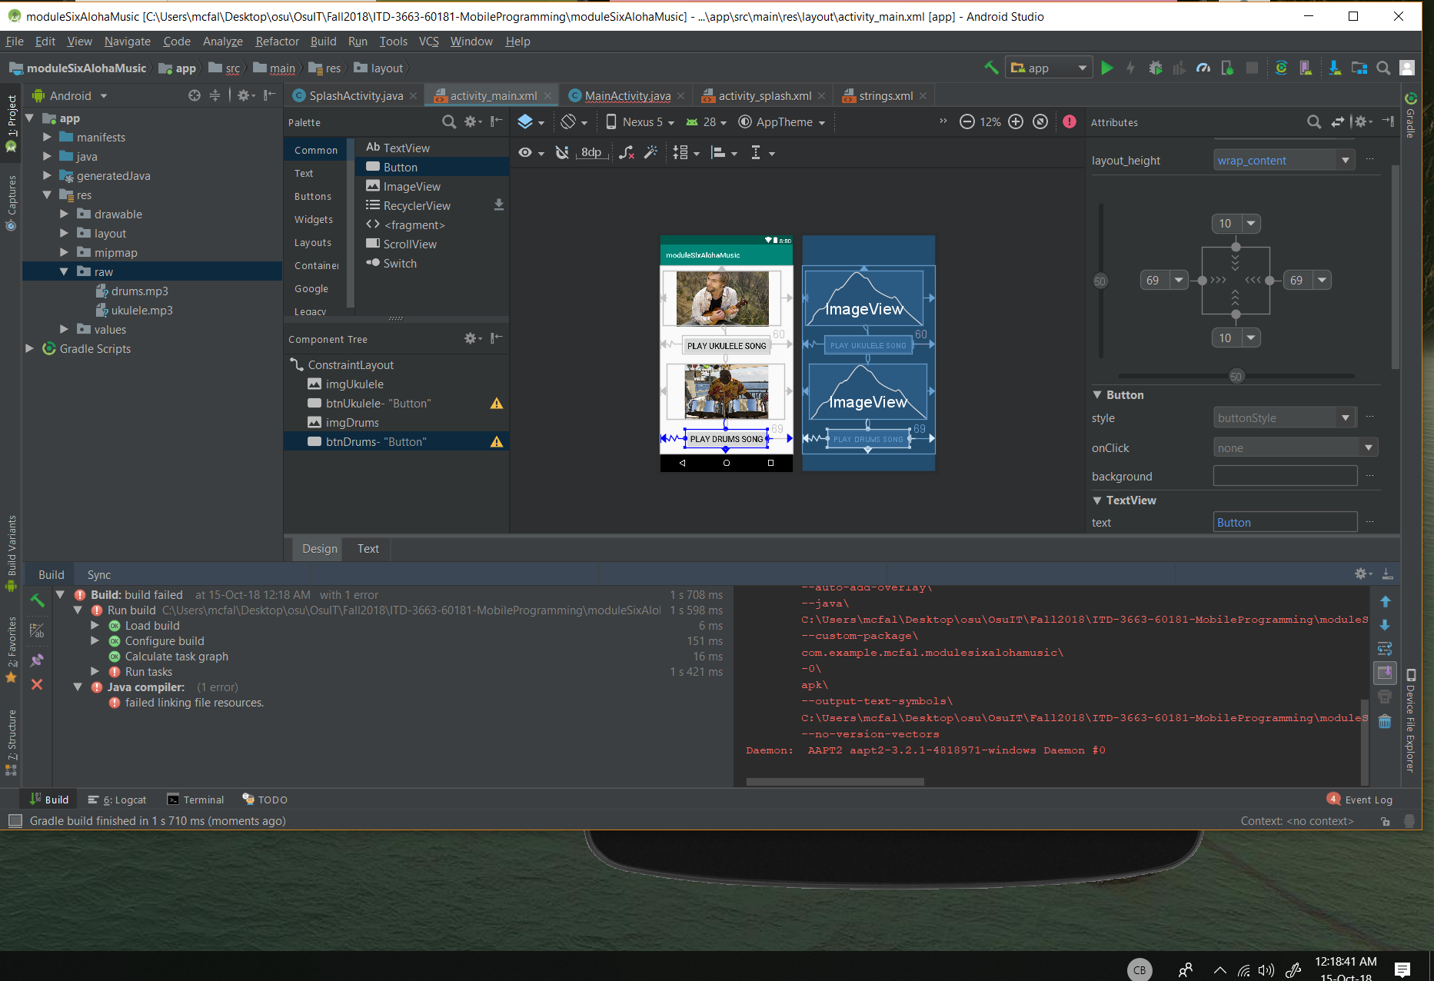

Ran into a bit of a snag with linking and I don’t know what the problem is.

Never mind the height and width parameters needed the “dp” after them for each of the pictures. After that it worked fine.

